**Java Arrays:**

Java array is an **object** which contains elements of a **similar data type.**

We can store only a **fixed** set of elements in a Java array.

**Array in Java is index-based**, the first element of the array is stored at the 0th index, 2nd element is stored on 1st index and so on.

we can get the length of the array using the **length** member.

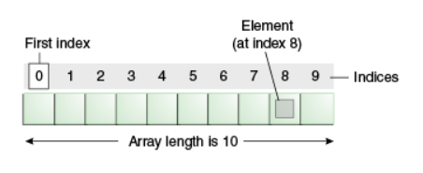

**Advantages:**

Code Optimization: It makes the code optimized, we can retrieve or sort the data efficiently.

Random access: We can get any data located at an index position.

**Disadvantages:**

Size Limit: We can store only the fixed size of elements in the array. It doesn't grow its size at runtime.

To solve this problem, **collection framework** is used in Java which grows automatically.

**Types of Array in java**

There are two types of array:

Single Dimensional Array

Multidimensional Array

**Single Dimensional Array in Java:**

Syntax to **Declare** an Array in Java

dataType arr[];

**Instantiation** of an Array in Java

arrayRefVar=new datatype[size];

**Declaration, Instantiation and Initialization of Java Array**:

**For-each Loop for Java Array:**

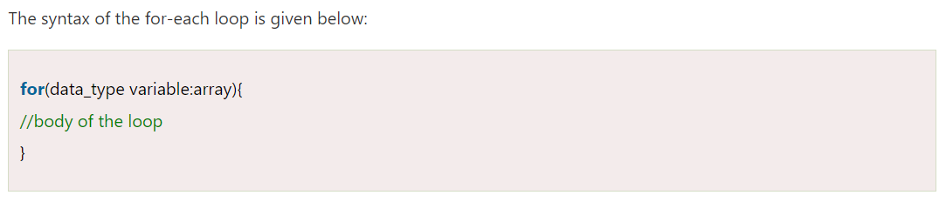

**Passing Array to a Method in Java:**

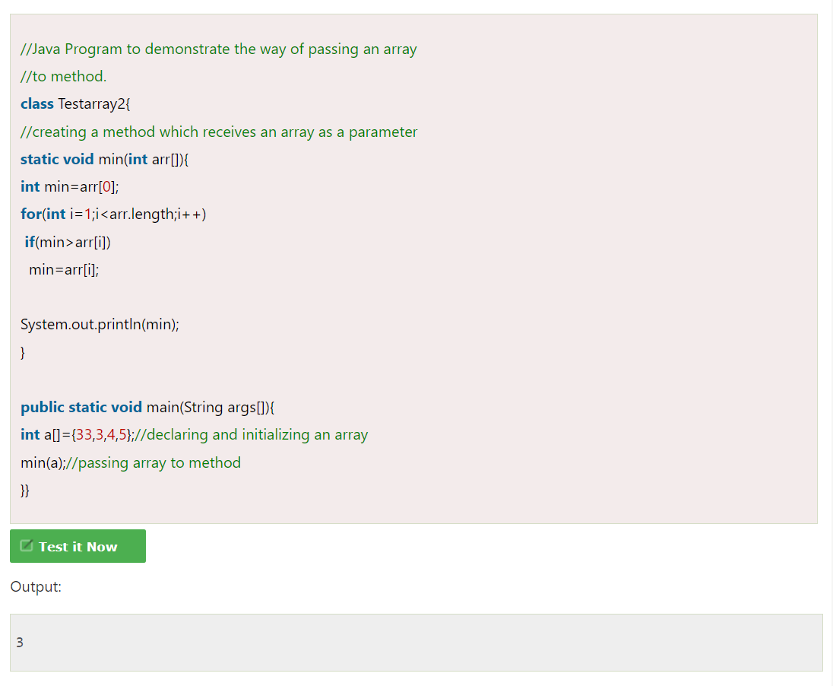

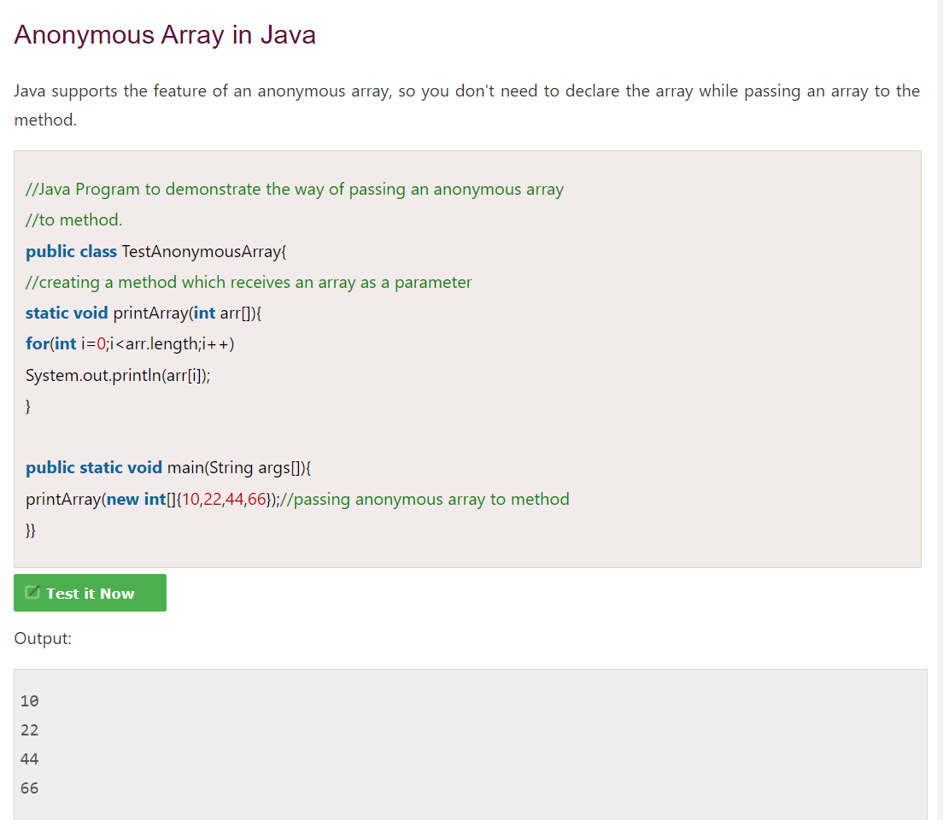

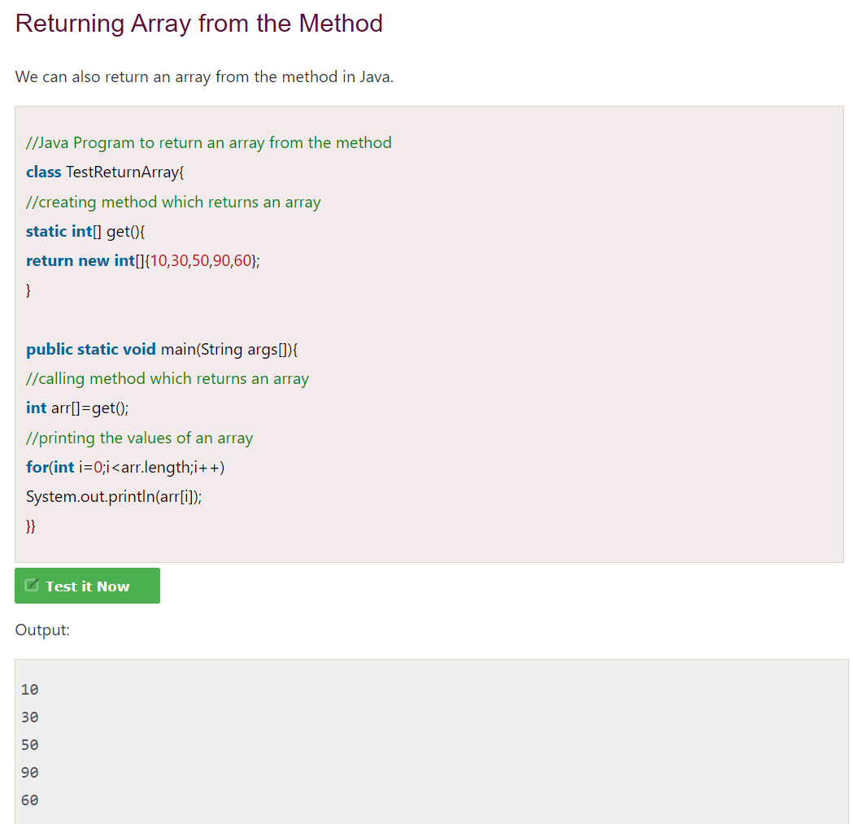

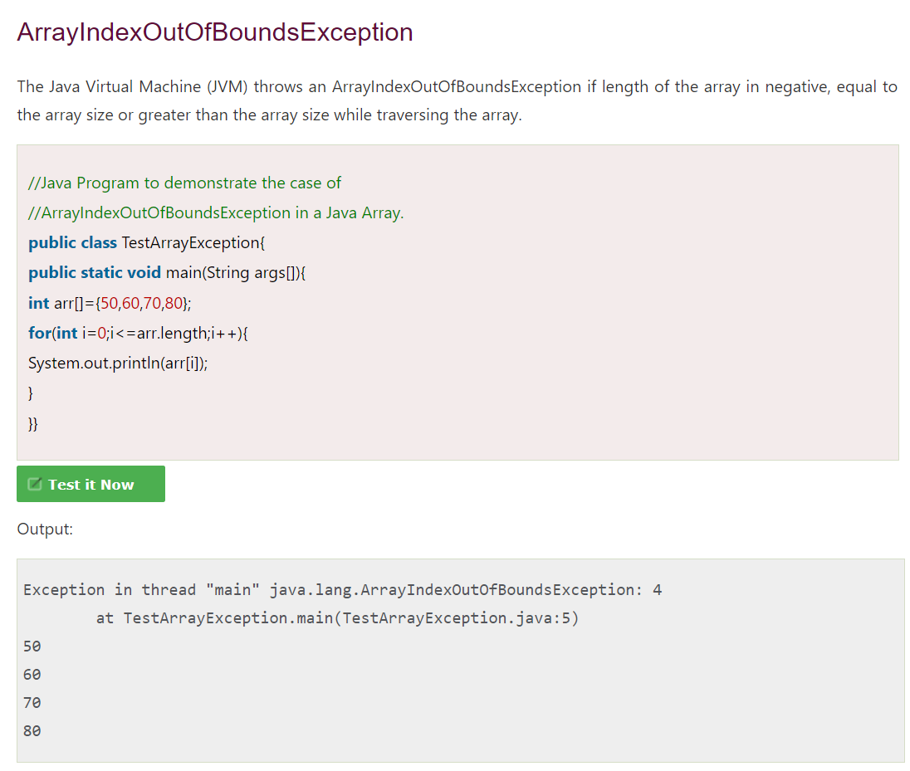

**Copying a Java Array:**

We can copy an array to another by the **arraycopy()** method of **System** class.

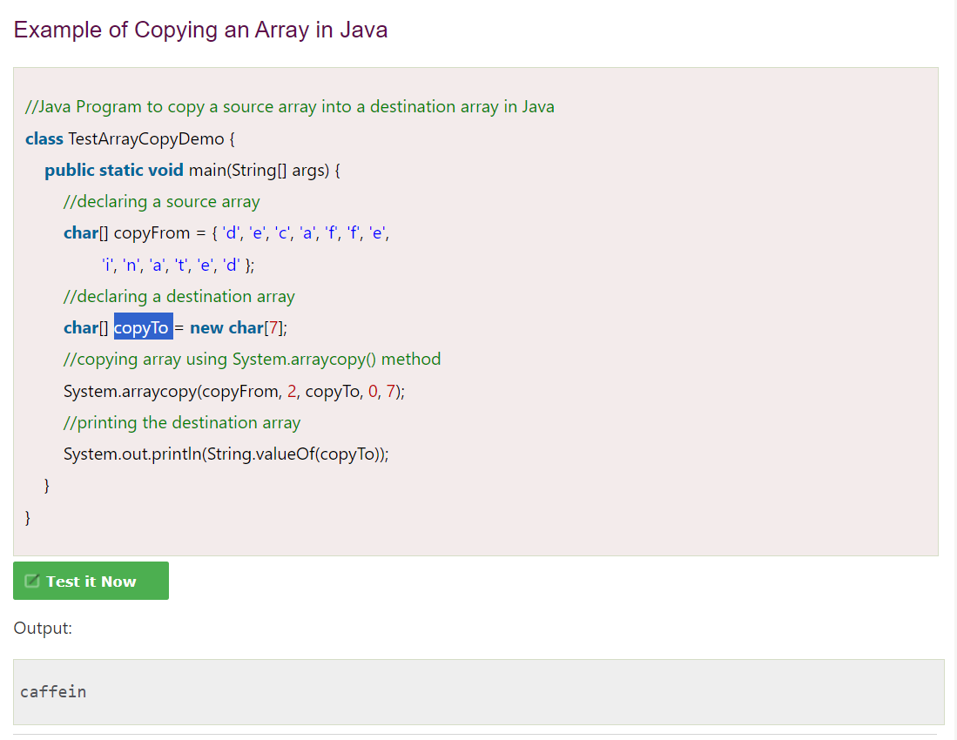

**Cloning an Array in Java:**

If we create the clone of a single-dimensional array, it creates the deep copy of the Java array. It means, it will copy the actual value.



